Budget Tracking using Blockchain

Now-a-days to ease user work many online applications are available which can track user daily activity and in all human the biggest activity is to monitor their expenditure and available budget limit so they can be in limit of expenditure to avoid unnecessary debt.

All existing applications are based on single centralized servers and this server’s data can be easily tamper and there is no way to track such data tamper, sometime hackers can hack this server to crash and in such scenarios services will not be available. To overcome from above issues many applications are migrating to Decentralized Blockchain storage where data will be stored at multiple nodes in a decentralized way and if one node down then services can be access from any other working nodes.

Blockchain stored each record as block or transaction and associate each block with unique hash code, while storing new record Blockchain will verify hash code of all previous blocks and if data not tamper then all blocks will generate same hash code and verification get successful and if block data alter then it will result into incorrect hash code and data alteration will get detected. Hash code verification of Blockchain make it tamper proof and impossible for data alteration.

Data can be store in Blockchain using smart contract and this smart contract can be designed using SOLIDITY code. Smart contract contains functions to store and get data from Blockchain and to store Budget data we have designed following smart contract

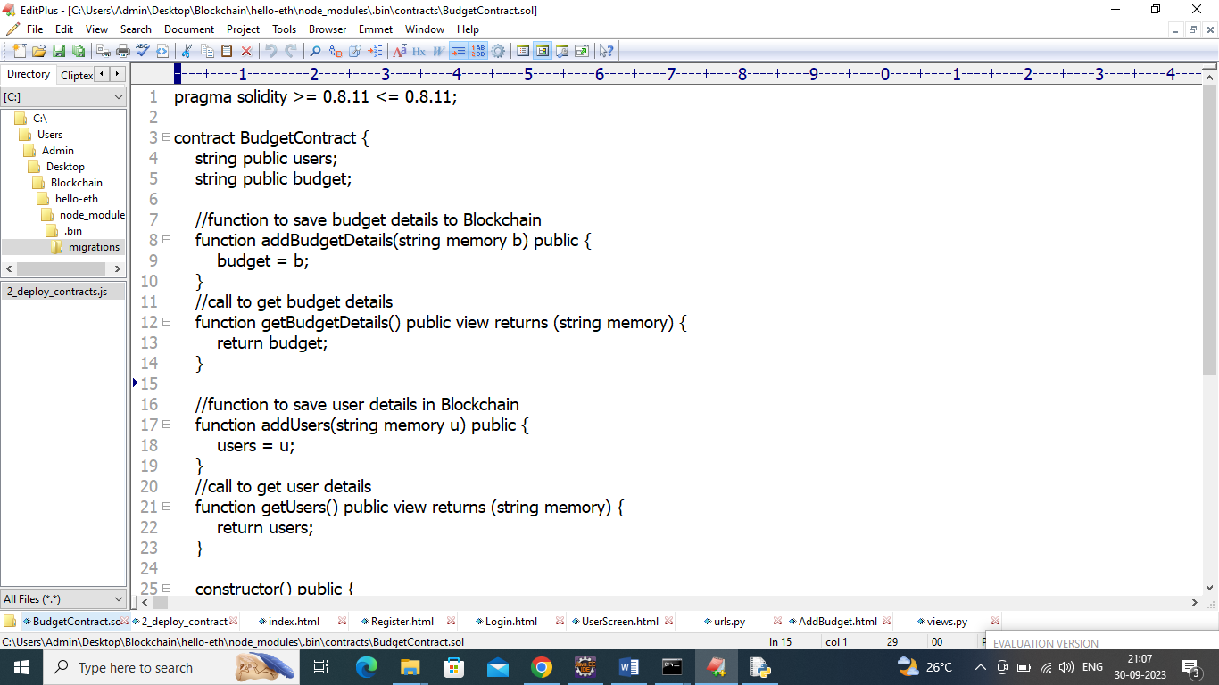

In above contract we have defined functions to save budget and user details and now we need to deploy above contract in Blockchain ETHEREUM by following below steps

1. First go inside ‘hello-eth/nodemodules/bin’ folder and then find and double click on ‘runBlockchain.bat’ file to start ETHEREUM tool and will get below screen
2. 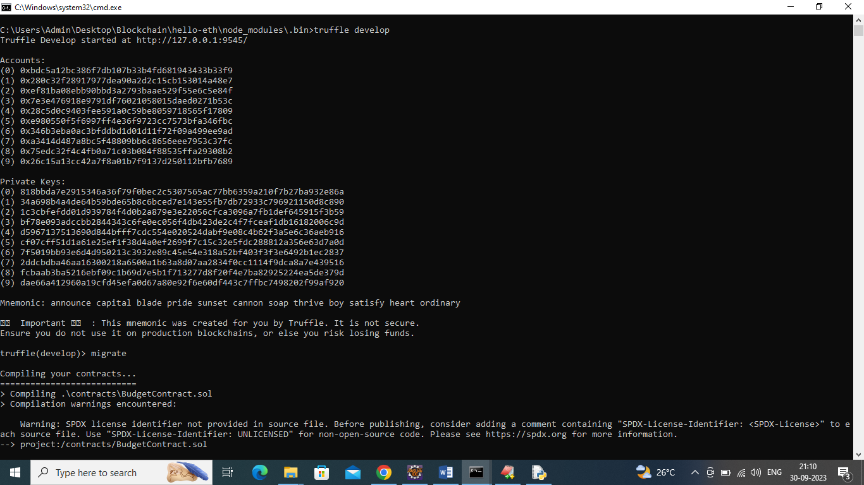
3. In above screen Blockchain ETHEREUM generate some default account and private keys and now type command as ‘migrate’ and press enter key to deploy contract and get below output
4. 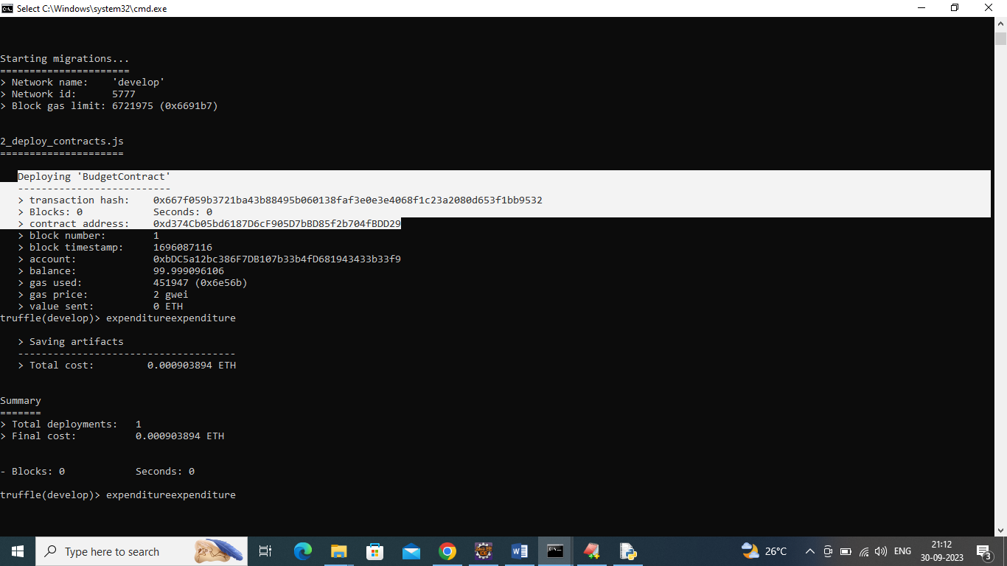
5. In above screen in white colour txt we can see ‘Budget Contract’ deployed and got contract address also and this address we can specify in python code to access smart contract to store and get budget data. In below screen showing python code calling smart contract using address
6. 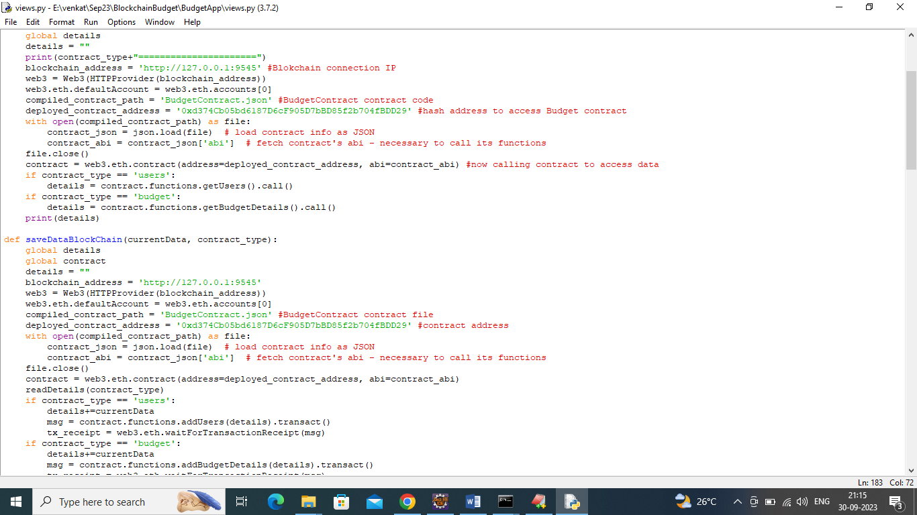
7. In above screen read red colour comments to know about contract calling from python to store and get budget data. In above black screen contract deployed and let that running.

SCREEN SHOT

Now double click on ‘run.bat’ file to start python server and get below screen

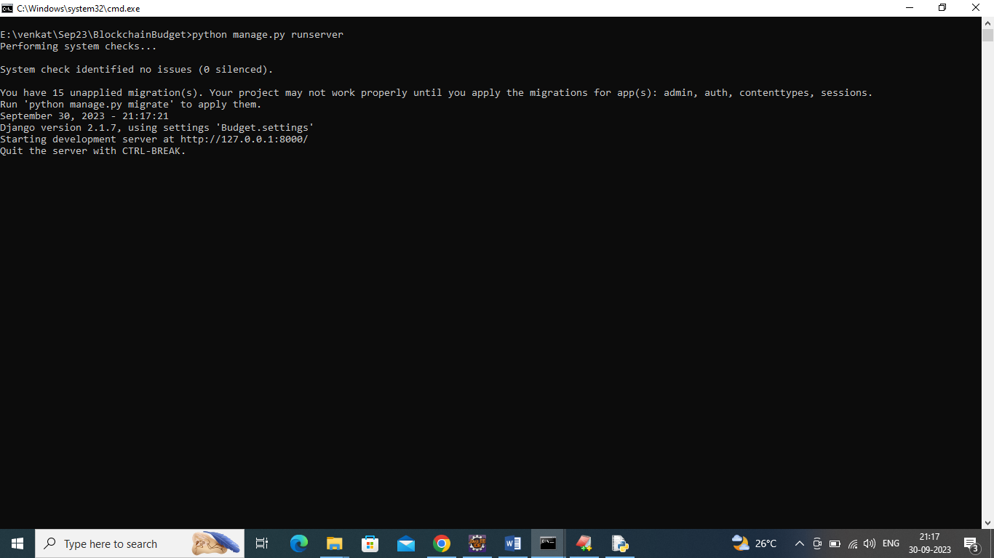

In above screen python server started and now open browser and enter URL as <http://127.0.0.1:8000/index.html> and press enter key to get below home page

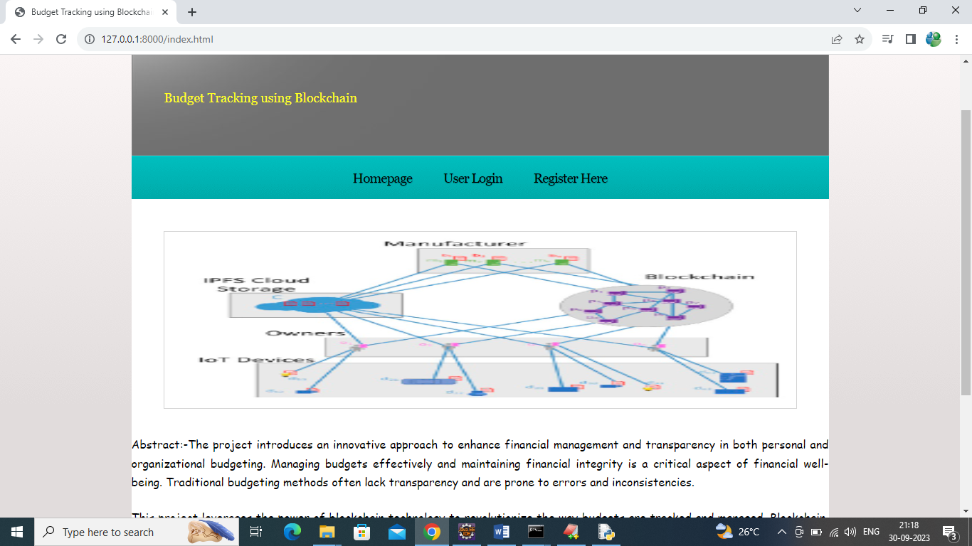

In above screen click on ‘Register Here’ link to get below signup screen

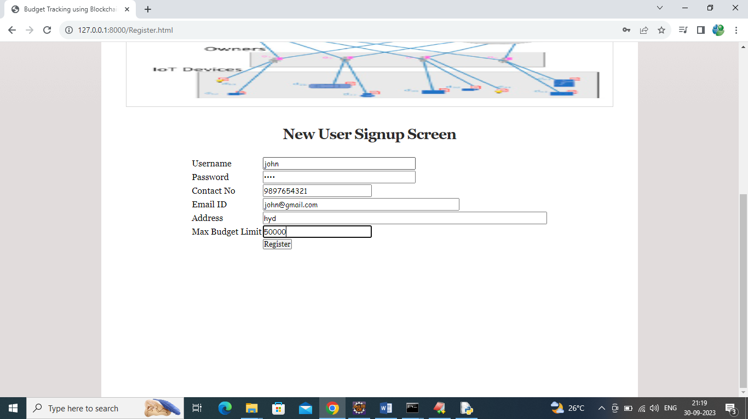

In above screen user is entering signup details with max budget limit and then press button to get below output and this limit will notify user upon tracking

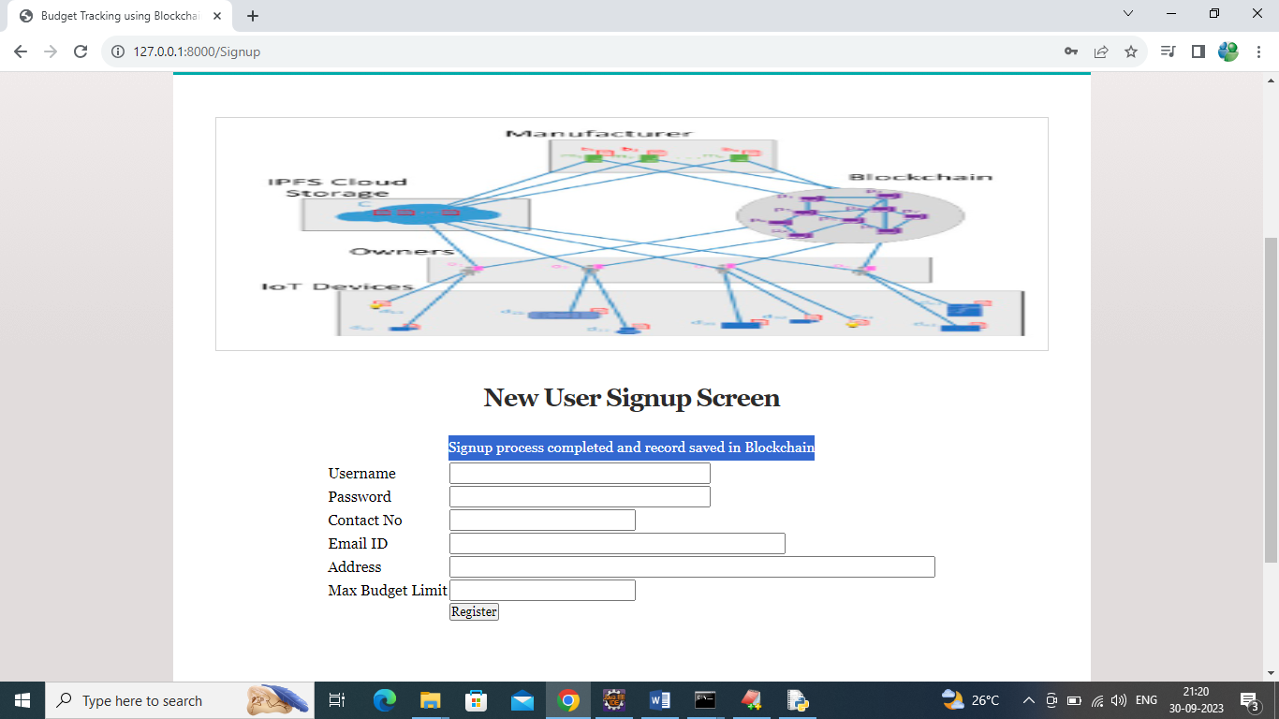

In above screen user signup details saved in Blockchain and now click on ‘User Login’ link to get below login page

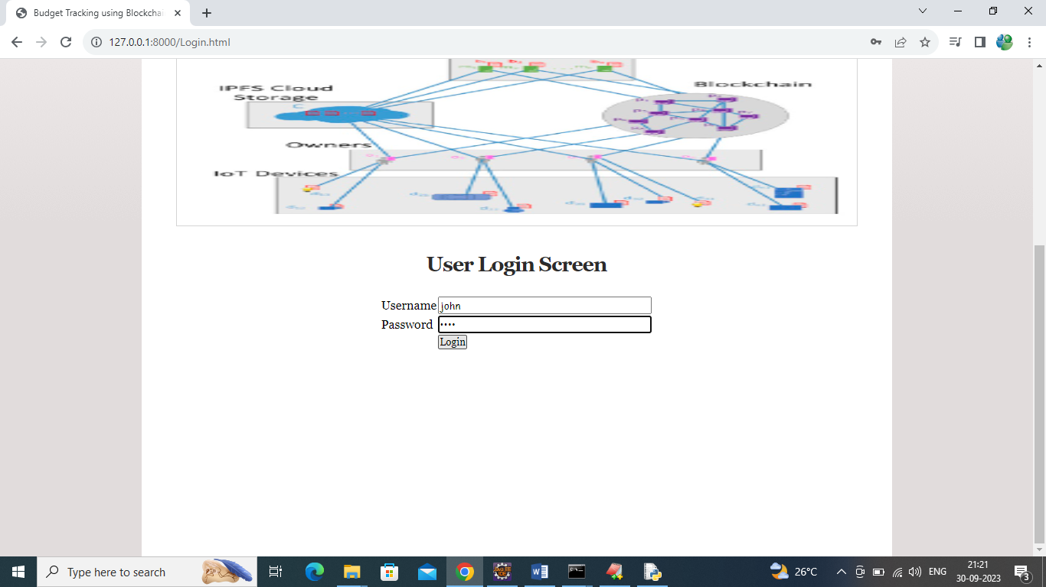

In above screen user is login and after successful login will get below page

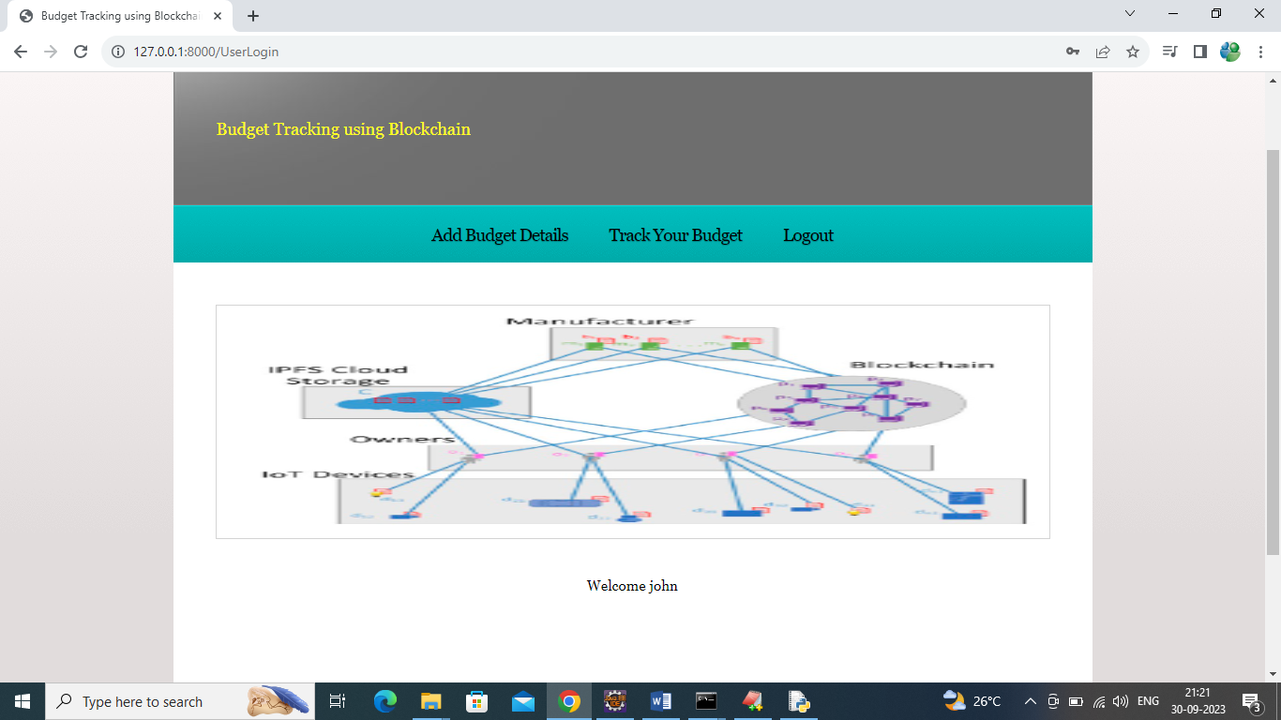

In above screen user can click on ‘Add Budget Details’ to add all expenditure of future budget details

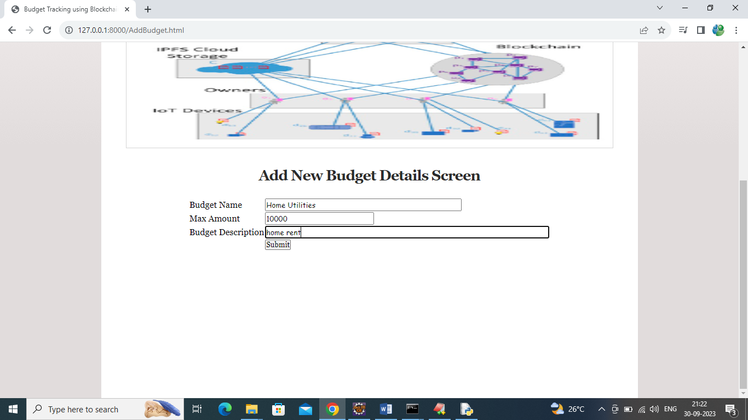

In above screen user is entering some home utility details and then press button to save budget details and get below page

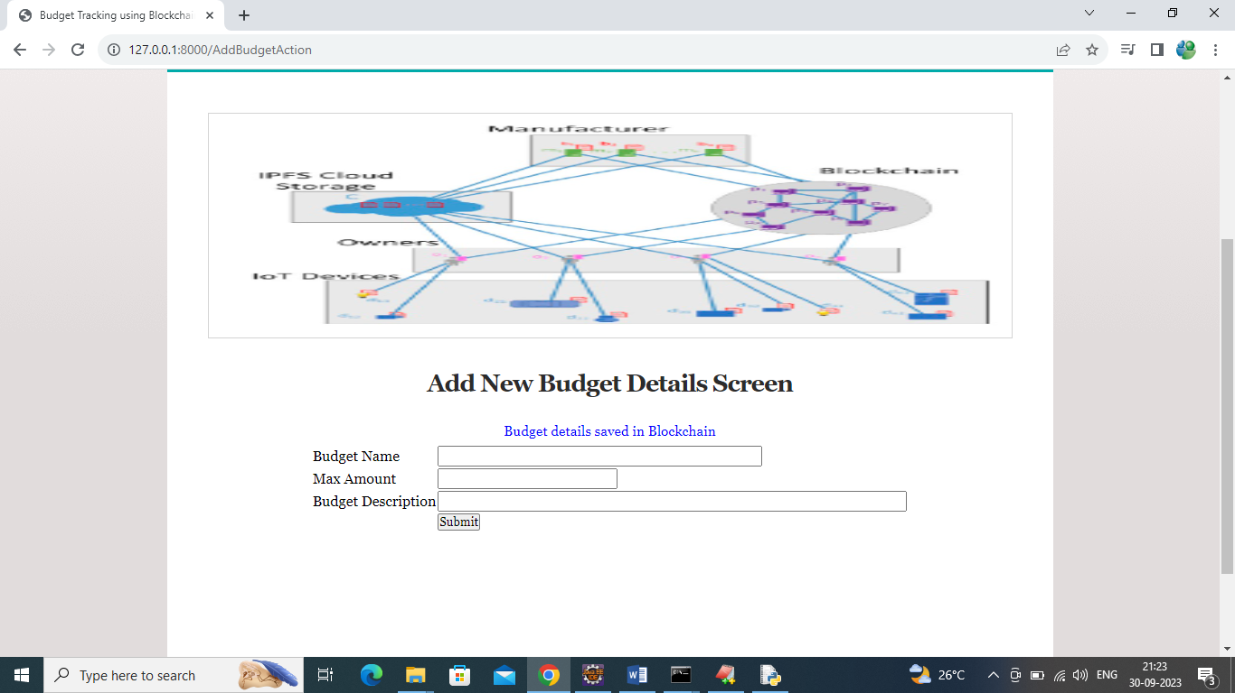

In above screen budget details added in Blockchain and similarly by using this function you can add any number of budget expenditure details. Now click on ‘Track Your Budget’ link to view all expenditure details

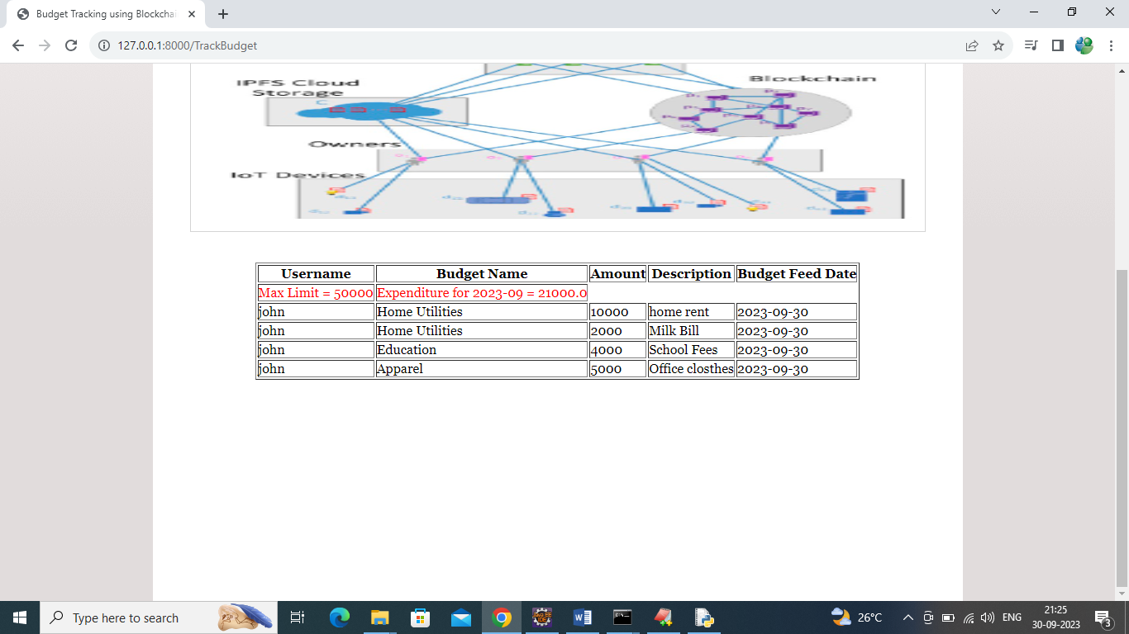

While tracking in above screen in red colour text user can see max budget and then can see month wise total expenditure/budget in red colour text and then in remaining rows can see each expenditure with all details. So by using above screen user can easily track or understand his budget with all his expenditure monthwise.